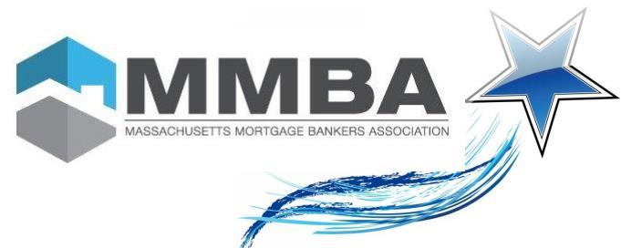
2025 Nomination Application

Nominee Name: ___________________________________________ (Please print clearly!)

Company Name: ______________________________________ Title: _______________________________

Address: _________________________________________________________________________________

City: ________________________________ State: _________ Zip: _____________________

Telephone: _____________________________ Email: ___________________________________________

I think this individual is a Rising Star Because:

Your information:

Name: ___________________________________________
Company Name: ______________________________________ Title: _______________________________
Address: _________________________________________________________________________________
City: ________________________________ State: _________ Zip: _____________________
Telephone: _____________________________ Email: ___________________________________________

Mail or Scan Nomination Form to:
MMBA, 185 Devonshire Street, Suite 601, Boston, MA 02110 / Phone (617) - 570-9114
Scan registration form to: dsousa@massmba.com

To submit additional information:

Contact Debbie Sousa at 617.570.9114 or email at dsousa@massmba.com

